AUSTRALIAN COLONIES
STAGE 3 ACTIVITY WORKSHEET
THE QUESTIONS BELOW ARE BASED ON THE PEOPLE AND STORIES YOU HAVE SEEN AND HEARD THROUGHOUT THE TOUR OF HAMBLEDON COTTAGE MUSEUM

ANSWER THE QUESTIONS TO COMPLETE THE FIND-A-WORD

- You met a mother and her son on the tour – what were their names?
- What was the name of the farm where the mother lives?
- What was Australia called when the Macarthur’s first came over?
- Where did the Macarthur family first come from?
- The family arrived in Sydney but then went to live at another place, what was the town called?
- When Edward Macarthur came back to Australia in 1851 what state did he become the acting Governor of?
- What animal did the Macarthur herd on their farm?
- What did they use this animal for?
- Where was Elizabeth Macarthur born?
- How many children did Elizabeth and John Macarthur have?

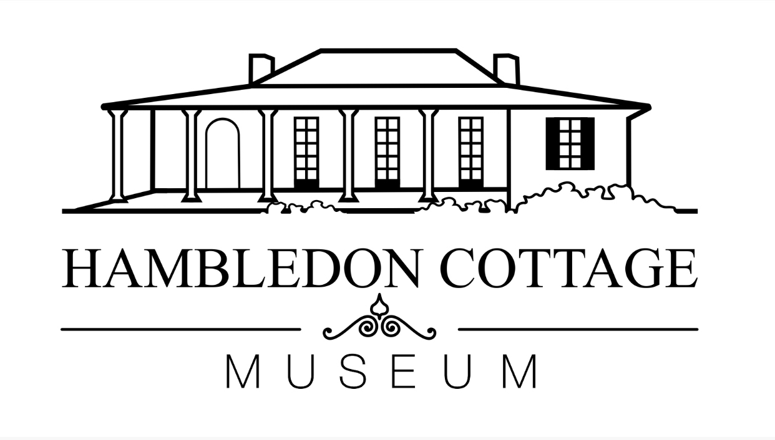

AUSTRALIAN COLONIES
STAGE 3 ACTIVITY WORKSHEET
FIND THE ANSWERS TO THE QUESTIONS ABOVE IN THE WORD SEARCH

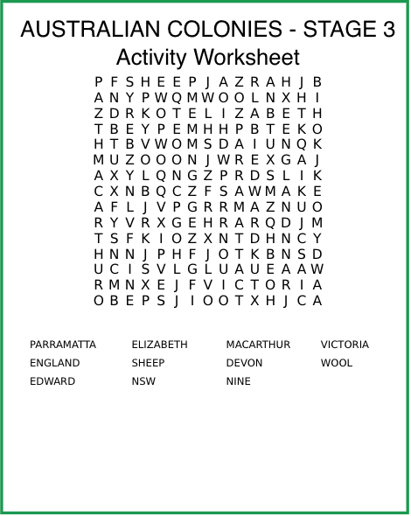
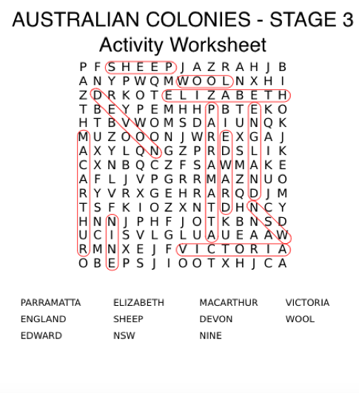
ANSWER KEY

