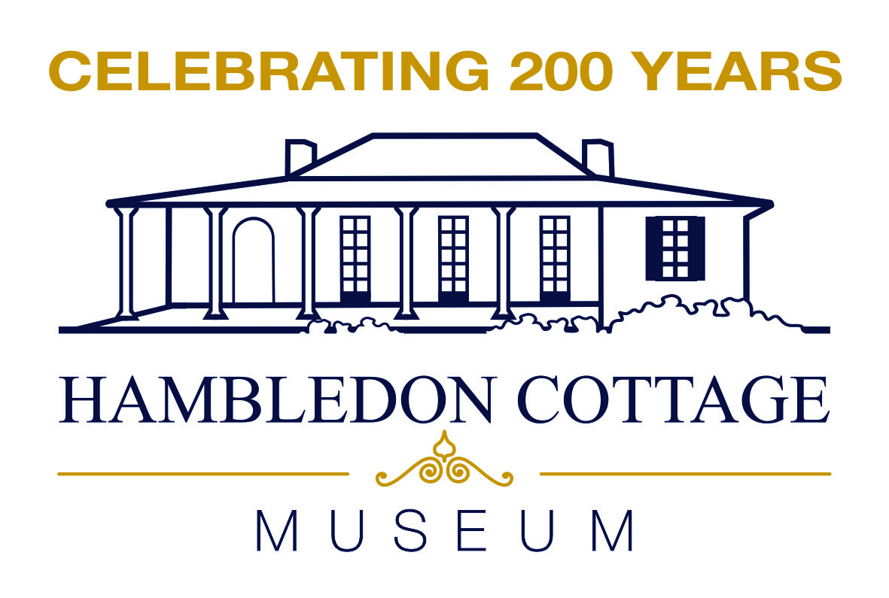
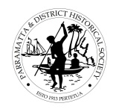
PARRAMATTA DISTRICT HISTORICAL SOCIETY
BICENTENARY CHILDRENS PROGRAM
15 April – 17 April 2024

“Children’s Colonial Activities” Games – 10.30am, Monday 15 & Wednesday 17 April 2024
Children over the centuries have played many games to amuse themselves.
Bring your children along to learn about and partake in numerous colonial games and activities.
Games include Quoits, Hoop Race, String art, Mix-n-Match, Jacobs ladder, Fly, Cup & Ball and learn to make a Thaumatrope. Games aimed for 5-12 year olds.
All children must be accompanied by an adult.
Cost: $ 5.00 (Family $10.00) per day Venue: Hambledon Cottage, Gregory Place, Parramatta
Time: 10.30pm–12.30pm, Bookings & Payment: Essential, prior to event
Monday 15 April - Event Code: CA15 or Wednesday 17 April – Event Code: CA17

BOOKING FORM

NAMES:…………………………………………………………………………………………………………………………………………………….

PHONE:……………………………………………………..EMAIL:…………………………………………………………………………………..

DAY DESIRED:
- Monday 15 April EVENT CODE: CA15 No. Children

- Wednesday 17 April EVENT CODE: CA17 No. Children

TOTAL COST: $
PAYMENT METHODS:
- CHEQUE to be payable to Parramatta & District Historical Society (post to PO Box 1384, Parramatta 2124)
- DIRECT DEPOSIT BSB 062223 ACCOUNT 900240
(State name & event code and email form to parramattahist@tpg.com.au)

