HAMBLEDON COTTAGE

Hambledon Cottage was built by John Macarthur in 1824 as a second house on his Elizabeth Farm estate. Notable occupants in the early days included General Sir Edward Macarthur, Archdeacon Thomas Hobbes Scott and Dr Matthew Anderson. The resident most associated with Hambledon is Penelope Lucas, former governess to Macarthur’s daughters. It was she who named the family “Cottage” after the township of Hambledon in Hampshire, England.
John Macarthur

Built of rendered sandstock brick in the Colonial Georgian style, the basic design seems to have been by Henry Kitchen. The joinery throughout is of Australian red cedar. Some of the internal ceilings and walls are still of lath and plaster whilst one bedroom still has its original ironbark floor.
In the kitchen block, an excellent example of a domed brick oven adjoins the open fireplace.
Edward Macarthur

Edward Macarthur, eldest son of the family, was the first occupant of the cottage. A professional soldier, he came back to Sydney in 1824 in connection with planning the defence of the colony.
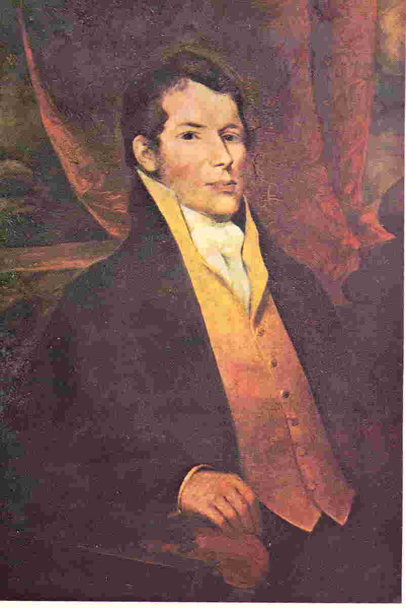
In December 1826, Elizabeth Macarthur wrote to Edward in England, “when the Archdeacon removes to Woolloomooloo we shall have the cottage vacant. Miss Lucas is determining on removing to it.” Born in 1768, Penelope Lucas came to Elizabeth Farm with Macarthur and daughter Elizabeth on his return from England in 1805. Miss Lucas, who was called “Mrs Lucas” or “Aunt Lucas” out of courtesy by the children, was governess to Elizabeth, Mary and Emmeline Macarthur. After her services were no longer required as governess, she remained at the Farm as companion and friend to Mrs Macarthur. When Macarthur became mentally ill in 1832, he drove his daughters Elizabeth and Emmeline out of the Farm and they went to live with Mrs Lucas at Hambledon. Penelope lived on at Hambledon until her death in 1836. John Macarthur had left her a small annuity in his will and the use of Hambledon during her lifetime.
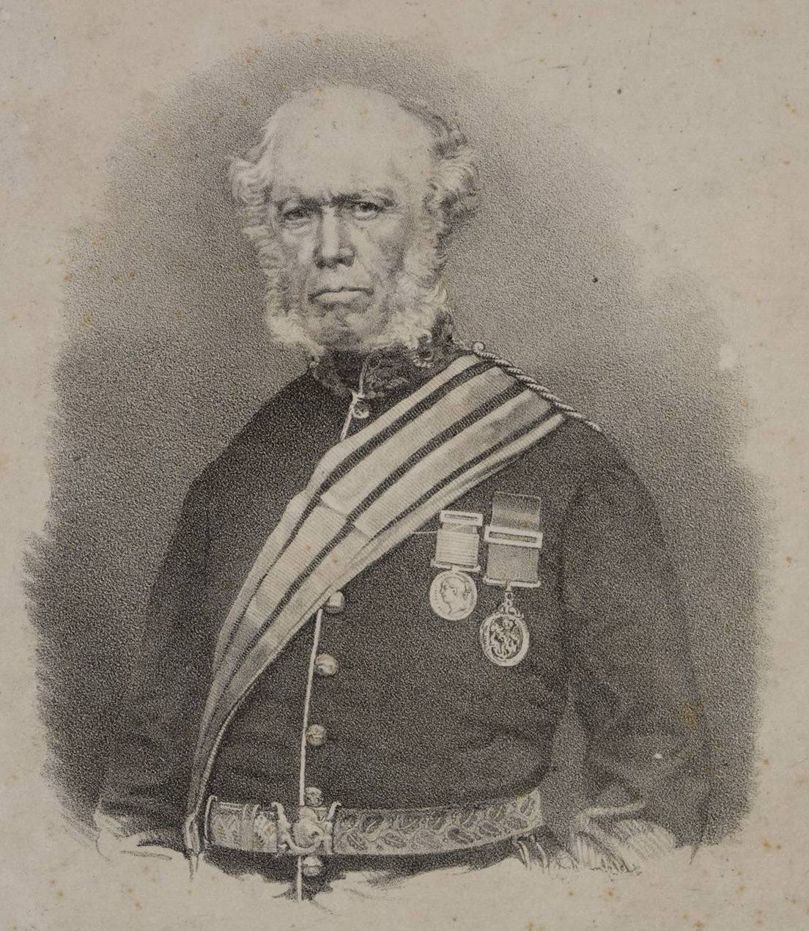
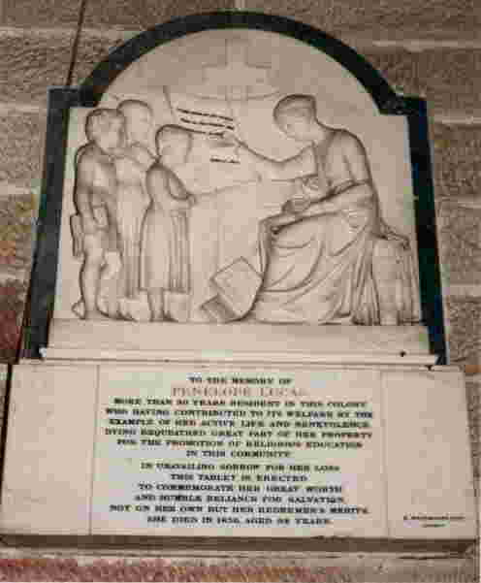

Memorial to Penelope Lucas in St John’s Church, Parramatta

Many friends and retainers of the family occupied the Cottage over the succeeding years including three governors. On the sale of the estate in 1881, it was acquired by solicitor, Septimus Stephen, who divided the property and sold each of the old buildings separately. Hambledon was to see a succession of tenants and owners. One renamed the property “Firholme”, a name which may still be seen on the remaining gates facing Hassall Street.

Early in 1950, the Whitehall Pharmaceutical Company acquired Hambledon, its many out buildings and its grounds of lawns, ancient oaks, peppers and a Spanish Cork tree. They donated the Cottage and the northern grounds to the Parramatta City Council thus securing the historical property for the future. Council restored the building with skill, renamed it Hambledon Cottage and in the mid 1960s leased it to Parramatta and District Historical Society for use as its headquarters and for display to the public as a house museum. The Society, which was founded in 1913, furnished the Cottage with loving care in the style of the 1820s-1880s period. The buildings and gardens took on a new lease of life and thousands of visitors are shown through it annually.

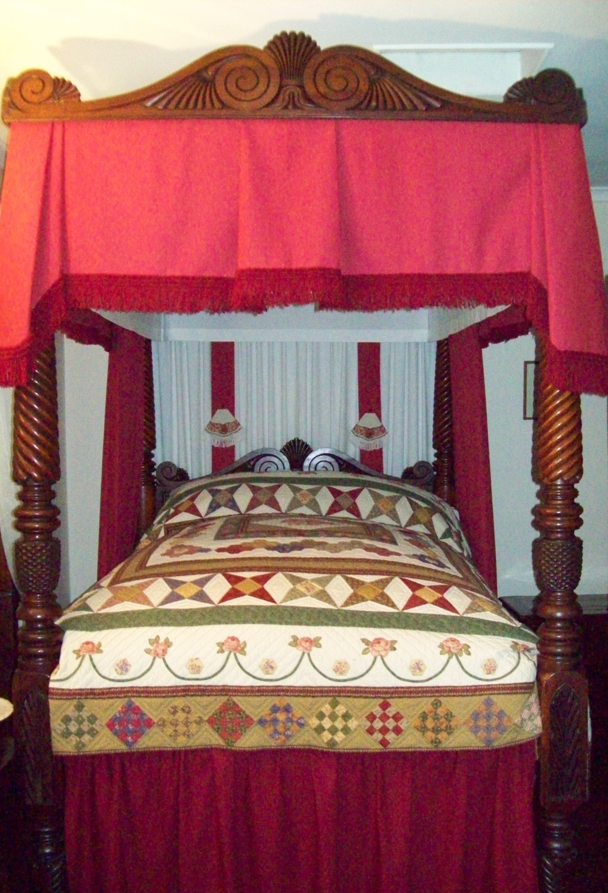

The bedroom has a magnificent four poster bed carved from cedar. It came from the pioneer Payten family of Parramatta and believed to have originally been in Old Government House, Parramatta.

Hambledon Cottage
Corner of Hassall Street and Gregory Place, Parramatta

Open for guided tours only

Fridays, Saturdays and Sundays and most public holidays

Groups of 10 or more at other times by appointment

From 11.00am to 3.00pm, last tour.

Entry Fee:
Adults $ 10.00
Concessions $ 8.00
Children $ 2.00

School Programs
Hambledon Cottage can cater for groups of school children (35 maximum) with our specially developed programs – student fee
Stage 1 & 2 $8; Stage 3 $10.

Contact Details :
Parramatta & District Historical Society

Phone/Fax: 9635-6924

Email:
parramattahist@tpg.com.au

Web: www.parramattahistorical.org.au
www.hambledoncottagemuseum.org.au
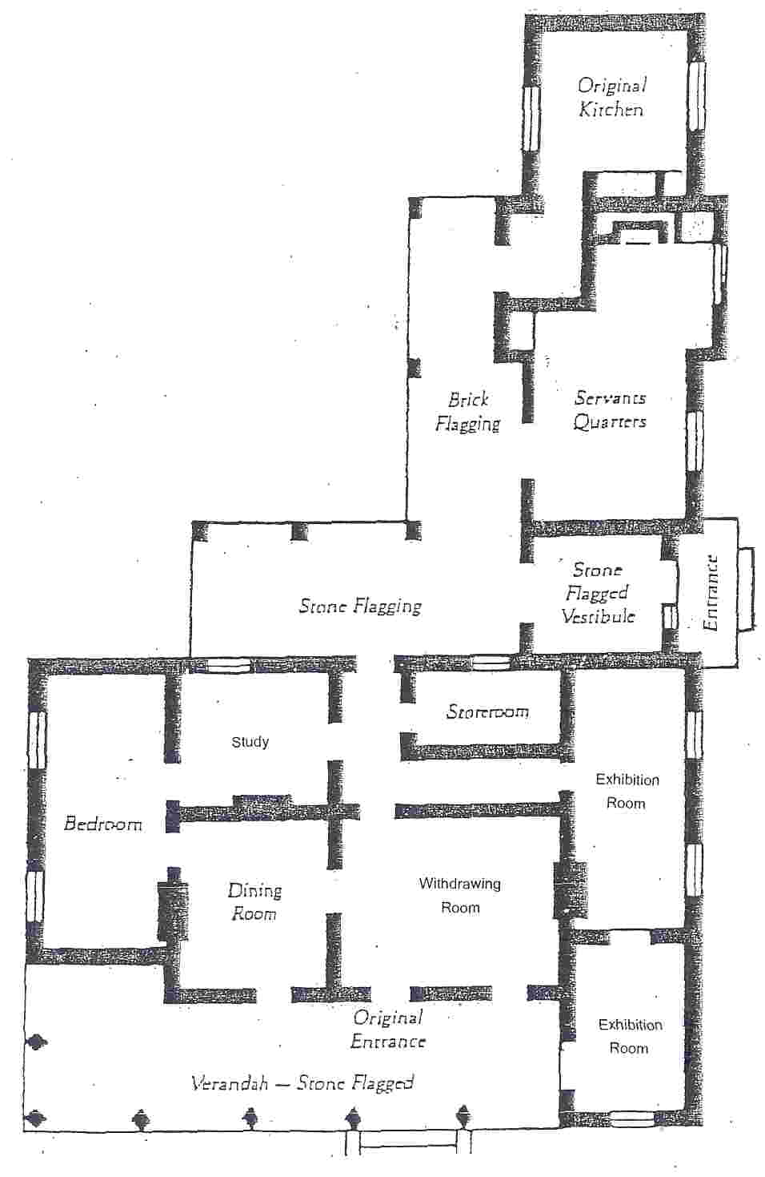
Hambledon Cottage layout

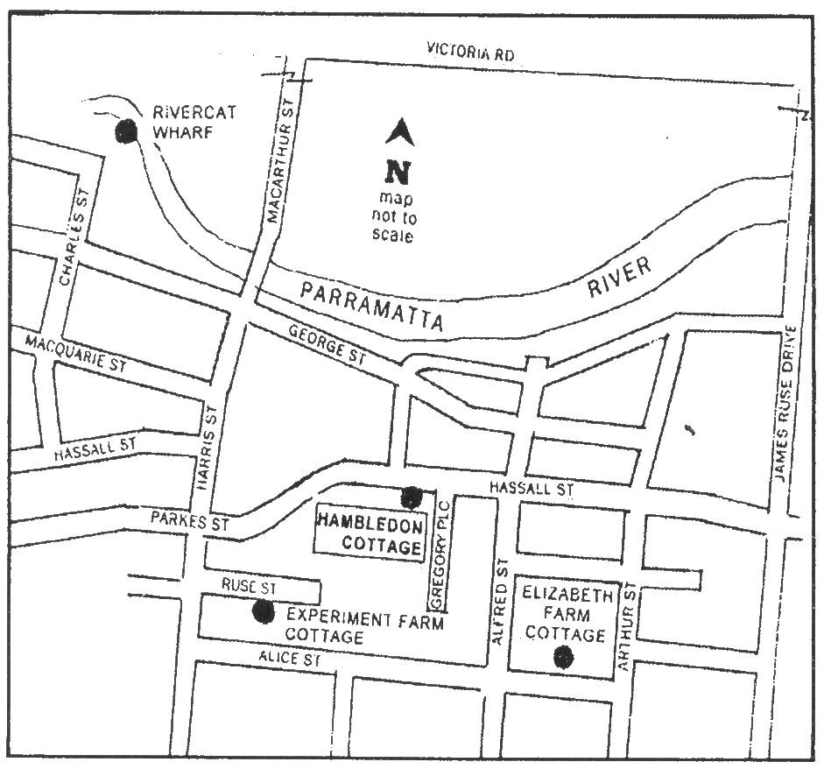
Location of Hambledon Cottage

Printed March 2023

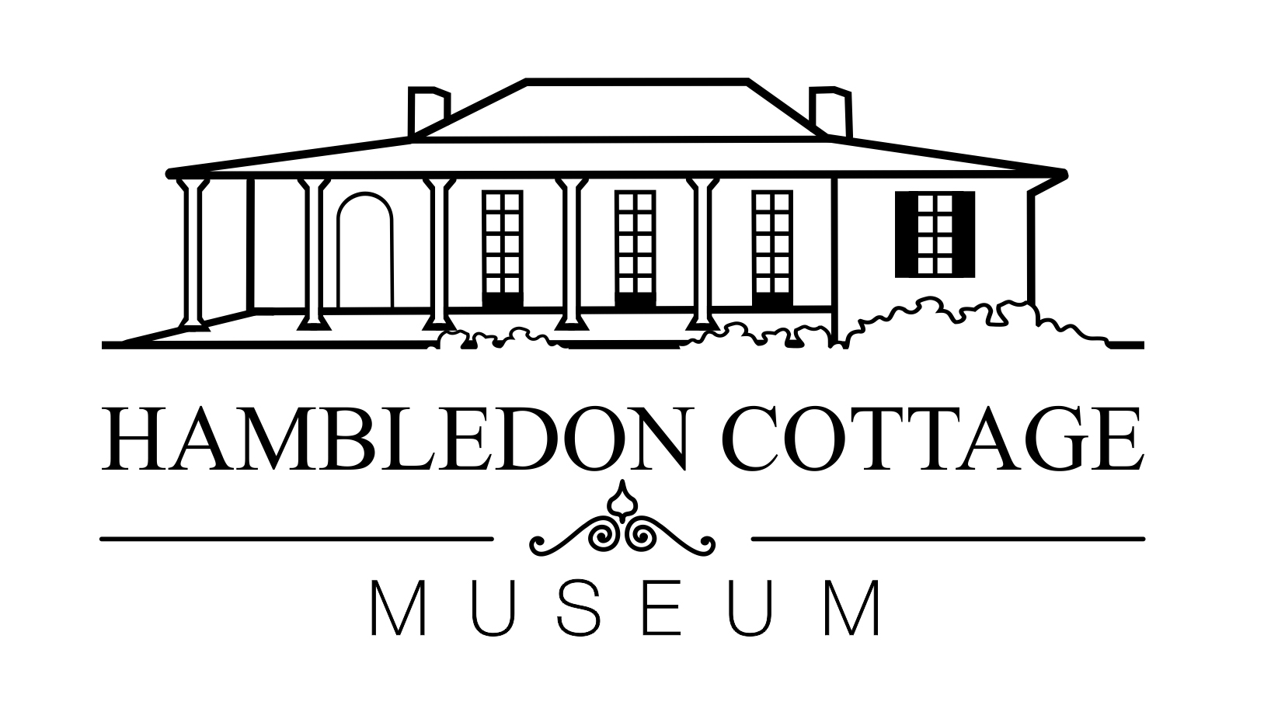
Managed by

Parramatta & District Historical Society

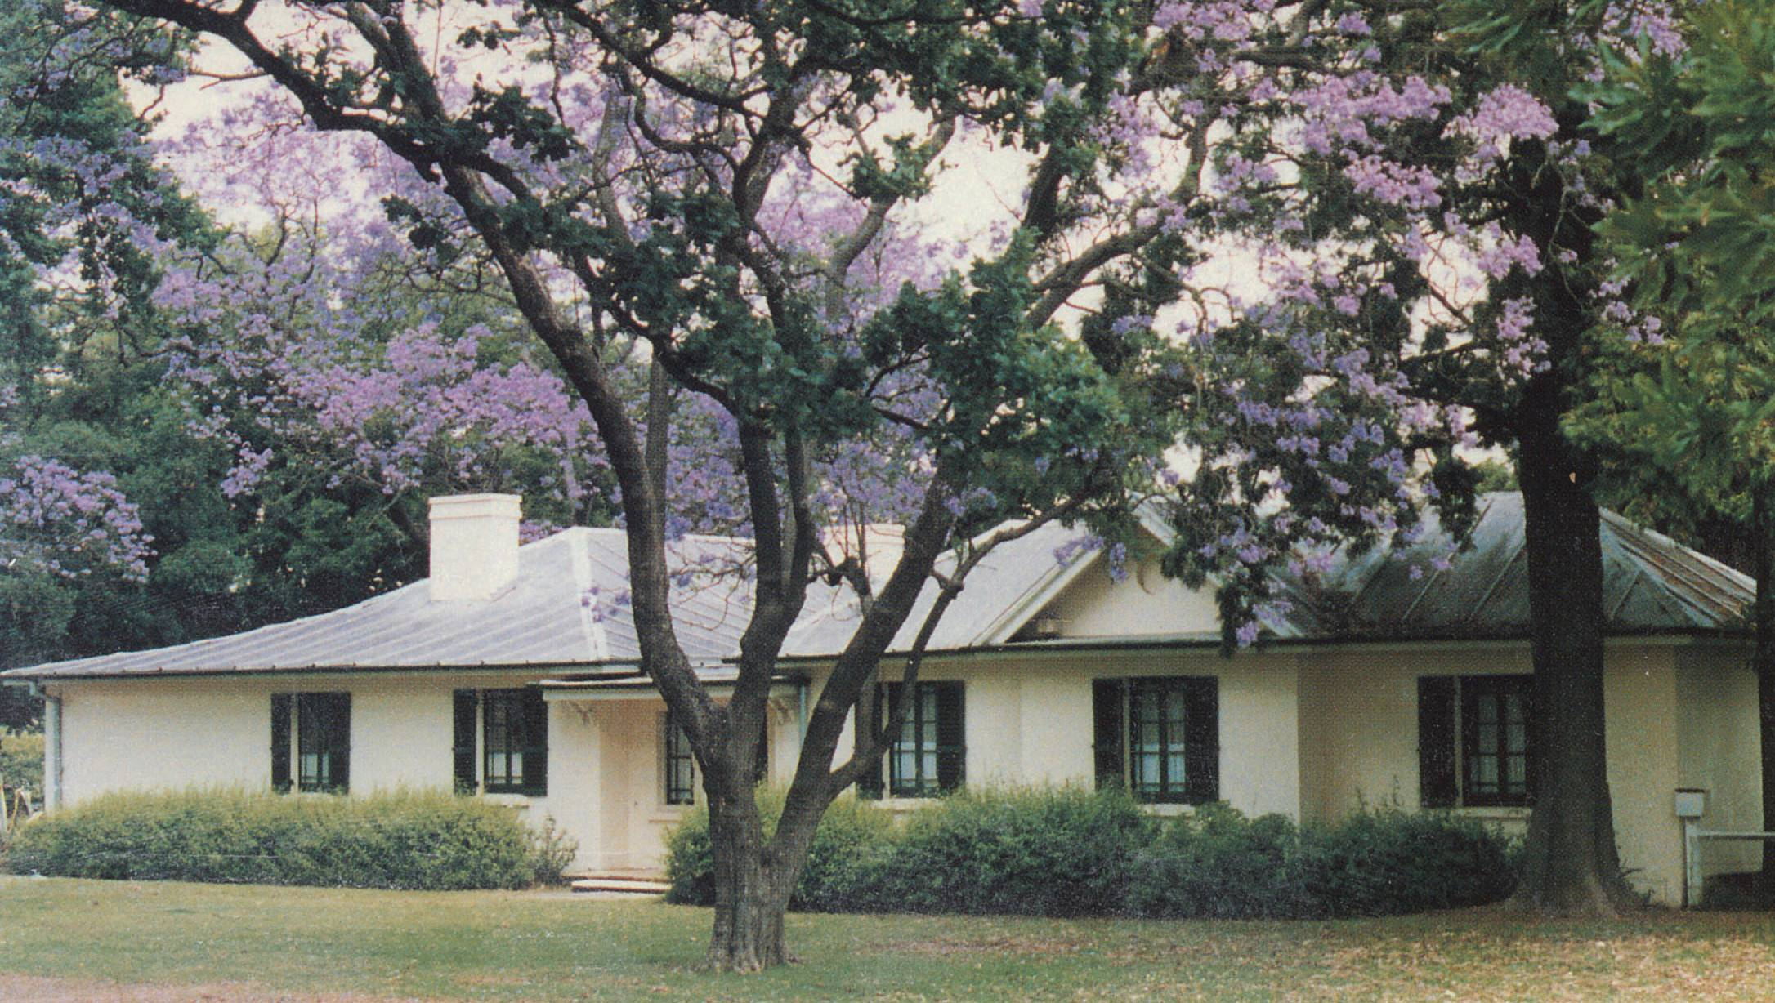

Welcome to
Hambledon Cottage

An elegant Colonial Georgian cottage built by John Macarthur in 1824

Discover 19th century lifestyle

