APPLICATION TO HOLD AN EVENT AT HAMBLEDON COTTAGE


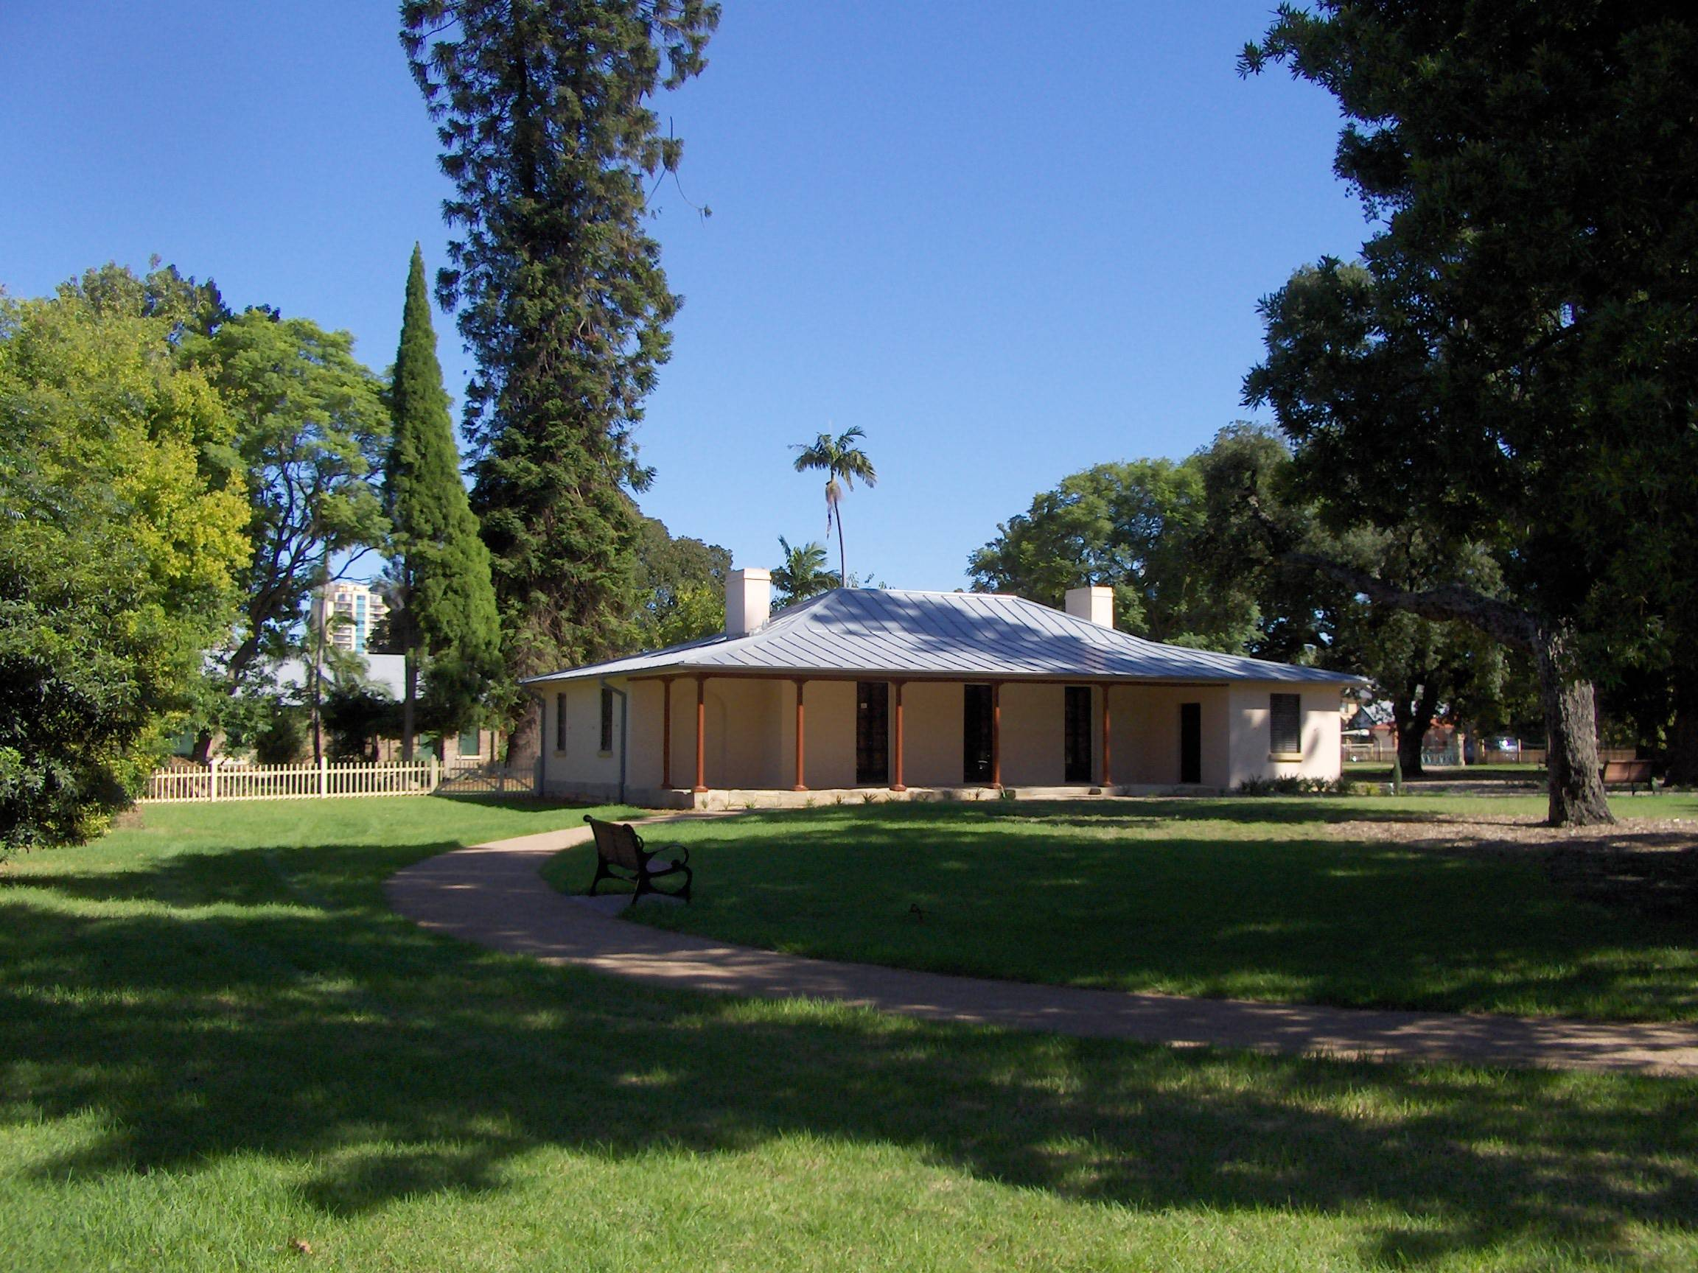
- Hirer
Name: ..................................................................................................................................
Postal Address: ......................................................................................................................
..........................................................................................................
Home Phone: .............................................Mobile ..........................................................
Email Address: ..........................................................................................................
Fax: ......................................................................

- Fees
A fee will be charged for the use of the Hambledon Cottage grounds, based on the nature, size and time of the event. The level of this fee will be assessed after receipt of the application. The normal fee for wedding ceremonies is $200.00 and for photographs only is $150.00.
A non-refundable holding deposit (administration fee) of 25% being required to secure a booking. Full payment of the remaining amount (the event fee) is required at least 4 weeks in advance of the event.
Refunds of 50% of the event fee will be made due to adverse weather conditions if agreed with the Society at least an hour prior to the event, or for any other reason if advised at least 2 weeks prior to the event.
Payments should be made by cheque to the Parramatta and District Historical Society at PO Box 1384, Parramatta, 2124.

- Event Description
Events, such as Wedding ceremonies, Wedding photographs or similar events, are able to be held at Hambledon Cottage. Unfortunately, events cannot be held in any rooms within the cottage but can be held on the eastern verandah of the cottage or, subject to a maximum of 20 people, in the gardens behind the cottage. Photographs can be taken outside the cottage, or in the gardens behind the cottage (wedding party only).
Please describe the event planned to be held ..........................................................................................................................................................................................................................................................................................................................................................................................................................................................................
- Public Liability Insurance
The Hirer must ensure that any Third Parties engaged for the event, such as Event organiser, wedding celebrant, wedding photographer, etc., must have in place a Public Liability Insurance of not less than $10,000,000 for themselves and their legal liability (i.e. Workers’ Compensation, Liability insurance, etc.).
A copy of the Certificate of Currency for this Public Liability Insurance must be provided prior to or with the full payment of the Fee, otherwise the event cannot be held.

- Dates and Times
Events can be held at Hambledon Cottage between 9am and 6pm.
Please advise the date and times for the event
......................................................................................................................................................

- Estimated Attendance
How many people are expected for the event
......................................................................................................................................................
- Vehicle Parking and Site Access
There is a small carpark within the grounds available for car parking. In addition, there is further car parking available in Gregory Place.
No vehicles (motor or horse-drawn) are to be parked or moved across the grassed areas of the park.

- Noise
Noise from public address systems, amplifiers or musical instruments must be kept to a level that does not interfere with or cause nuisance to the use and enjoyment of other people in the vicinity of the event.

- Waste and Decorations
All waste, rubbish and litter, including cigarette butts, must be removed from the site or placed in the rubbish bin in the park.
Confetti, rose petals, party poppers and the like may not be used on the Eastern verandah of the cottage or within the cottage gardens.
No decorations, signage, etc. can be attached to the cottage building.
- Amenities
Limited toilet facilities are available for guest at the event.
If required, a temporary domestic electricity supply can be provided. Please advise if needed.
A table and a few chairs can be provided for the event, if required. Please advise if needed.
.................................................................................................................................................................................................................................................................................................................

- Responsibility for any Damage
The Hirer is responsible for the cost of any damage caused in association with the event.

- Confirmation Of Booking
Confirmation of the booking will be issued by Parramatta and District Historical Society and forwarded to the Hirer, after approval of the event.

- Hirer’s Declaration
I have read and understood the foregoing and acknowledge that failure to observe the conditions of hire may result in cancellation of my booking.
I confirm that I am authorised to sign this declaration.

SIGNATURE::................................................................DATE:.................................................
NAME:.........................................................................................................................................

**************************

(January 2013)

